# Tableau Workshop -

## Infographic from SQL Data (3 hours)

This workshop will involve creating a SQL query for the Northwind database, exporting the results to a .csv file, importing the .csv file into Tableau, and creating a simple infographic from the data.

This will allow students to practice:

* SQL queries
* Exporting data
* Visualizing data with Tableau
* Creating a simple infographic

You will work as individuals on this project, but feel free to help each other. The project will consist of 4 distinct parts that will build on each other.

# Part 1 - SQL Query

Connect to the Northwind database using dBeaver. This is a NEW database connection

Host: database-postgres.cblhkpgfyab8.us-east-1.rds.amazonaws.com

Port: 5432

Database: Northwind

User: analyst

PW: m00nbase

Write a query (or queries) to generate this dataset for orders in 1997:

* order_id
* order_date
* product_name
* category_name
* quantity
* sale_amount (quantity * unit_price * (1-discount)
* profit ( sale_amount - quantity *product_cost)
* ship_country
* (customer) company_name

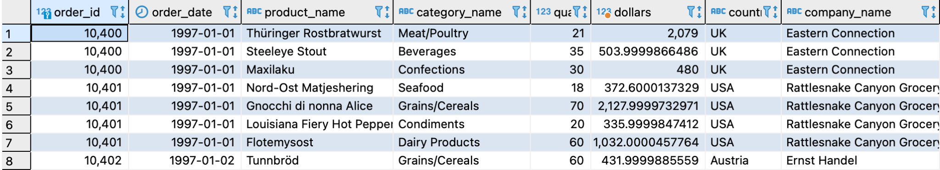

# Part 2 - Export Your SQL Results to .csv

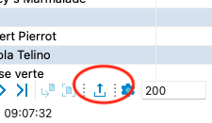

In dbeaver the export button looks like an up arrow.

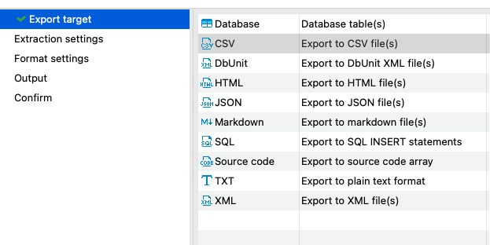

dBeaver will guide you through a few steps to export a .csv file. Click

Next->Next->Next->

choose a name for your download then press <Proceed>

# 

# Part 3 - Visualize your Data in Tableau

Use the .csv you created to make some charts in Tableau that will answer some sales team questions about Northwind sales in 1997:

* What were Northwind’s total sales $ by category in 1997? (Pareto or bar chart)
* Who were our top 10 customers by sales in 1997?
* What were our sales numbers by country?
* What were our profits month-by-month? (Waterfall or line chart)
* Any other 1997 sales information you think should be included

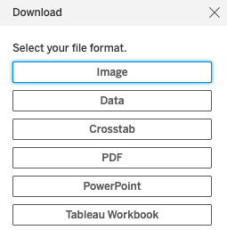

Save each visualization as a separate sheet in your Tableau workbook. When you are happy with your charts, save your work to Tableau Public. From there you can download your workbook as images or as a Powerpoint presentation.

Alternatively, you can take screenshots for use in your presentation or infographic.

# Part 4 - Create a 1-page Infographic

Use Powerpoint or Google slides (or any other tool you like) to make a 1-page infographic. Add text (in readable font) to explain context.

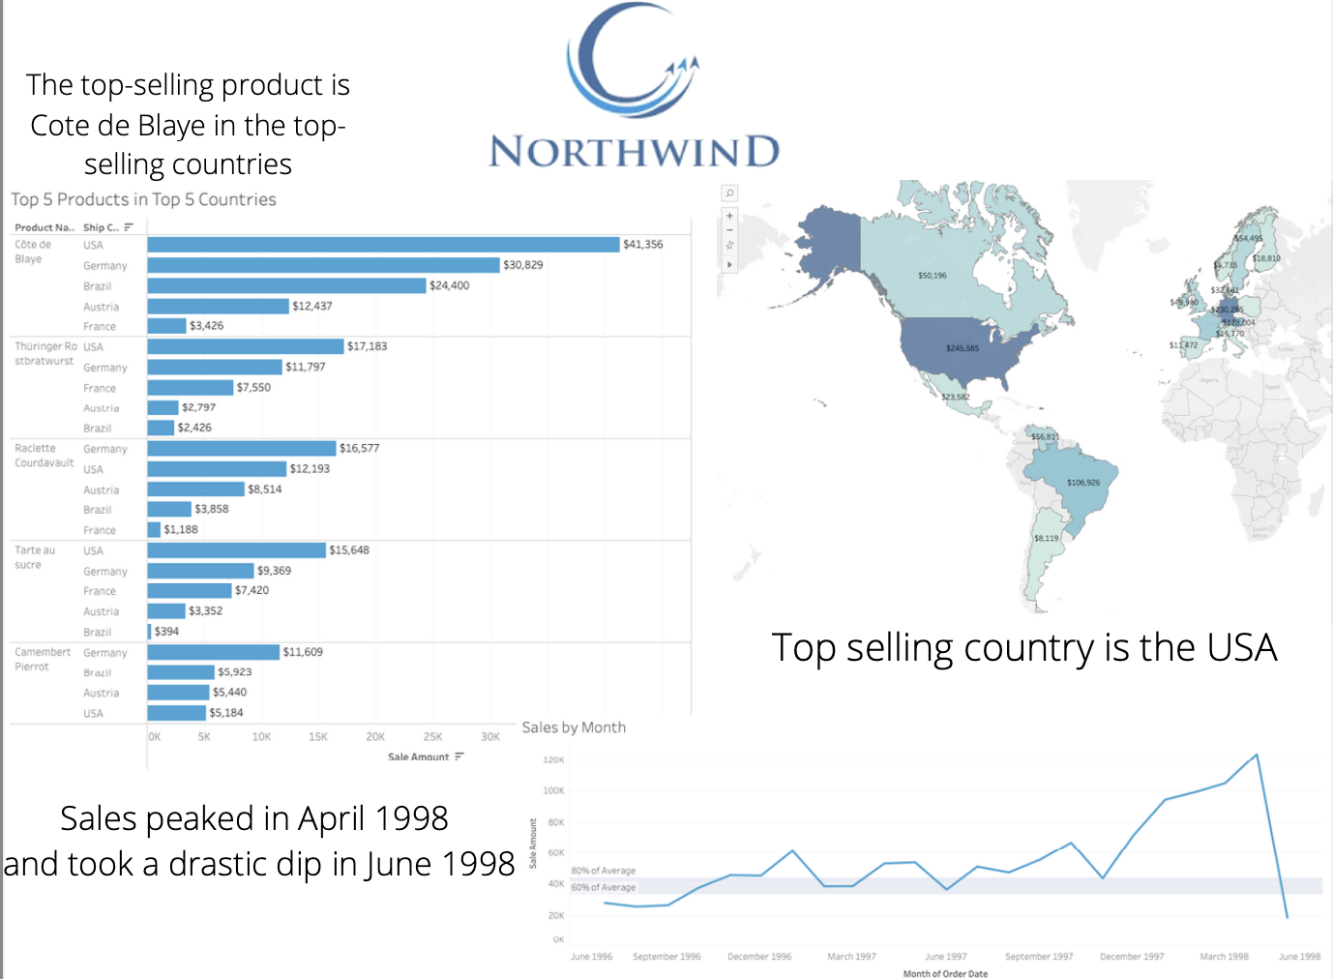

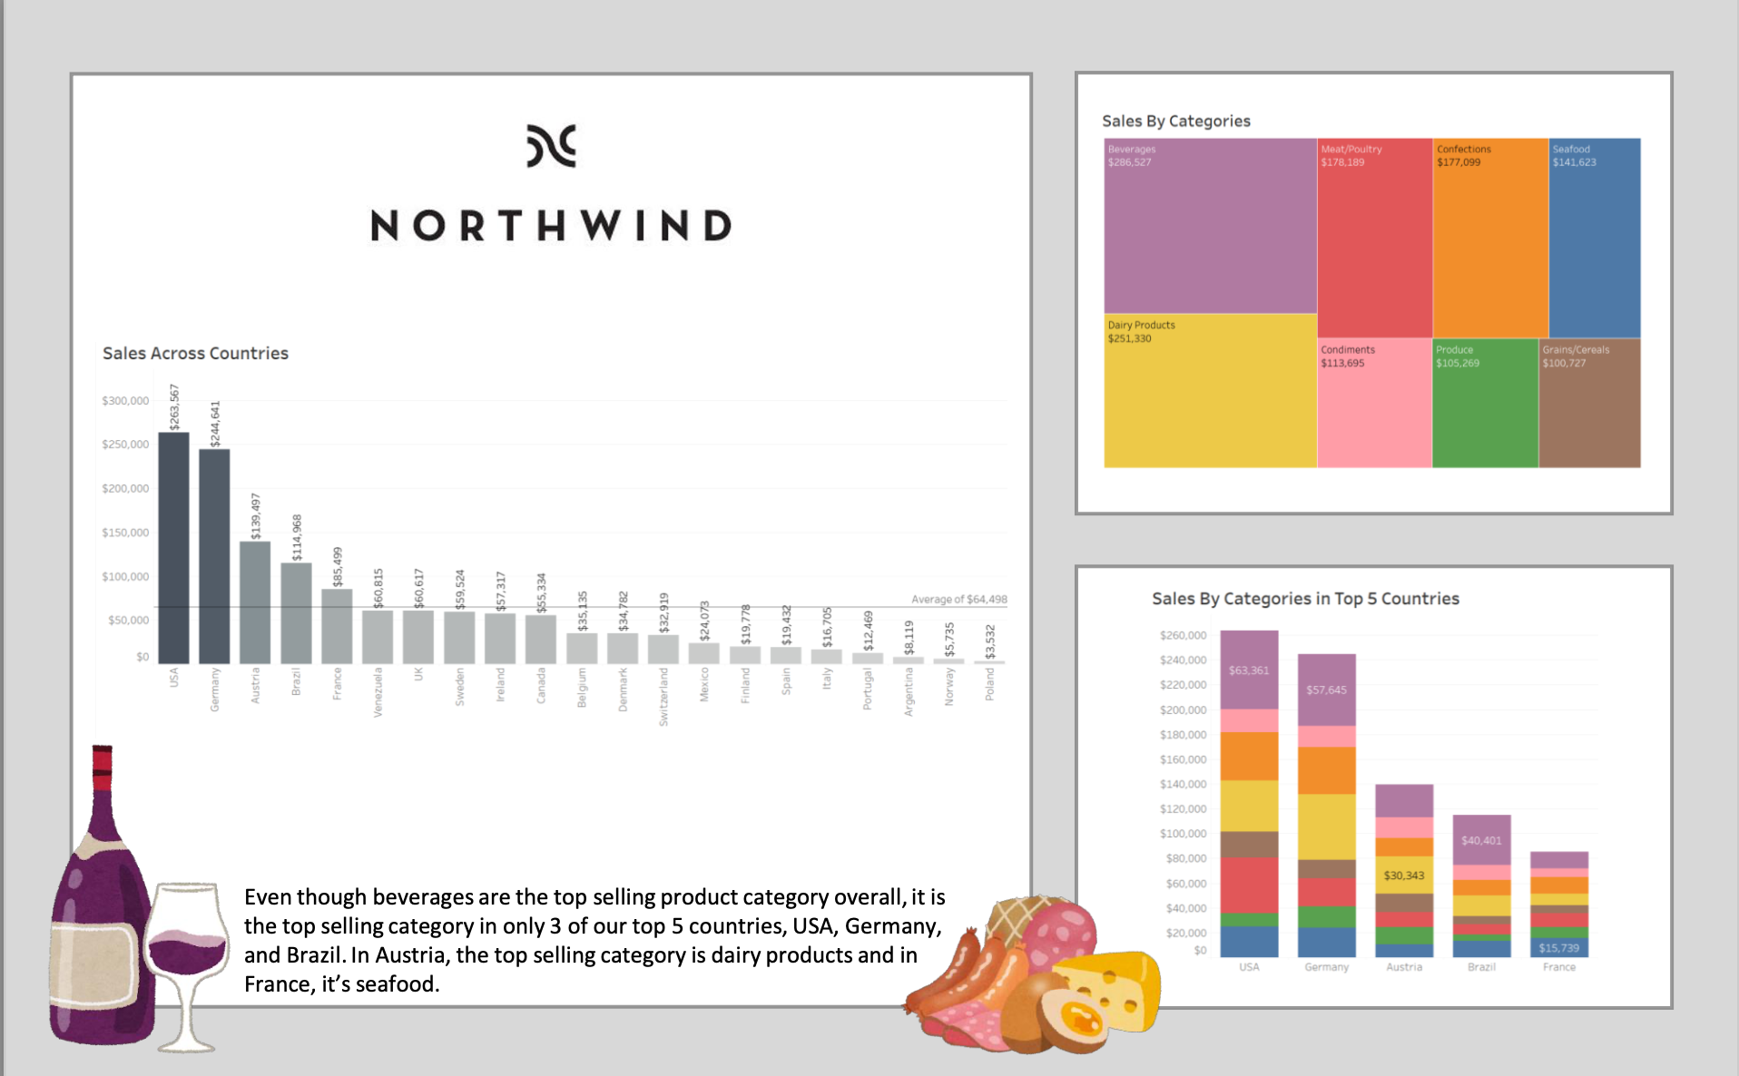

At the end of the day (~4pm) we’ll have some people show us their infographics. We’ll have a Slack thread for posting your infographic as well.

Waterfall charts step-by-step

1. Create a bar chart of a measure by some dimension (discrete time, categories)
2. Convert the bar chart to a Gantt bar
3. Add a “Quick Table Calculation” to change to “Running Total”
4. Create a new calculation called Waterfall and make it (-1*your_measure’)
5. Drag your Waterfall calculation into the mark size
6. Drag your measure into the mark color tile

Pareto charts step-by-step

1. Create a bar chart of count-of-something showing the discrete categories in decreasing order
2. Create a duplicate bar chart
3. Change one of the bar charts to a line chart
4. Change the line by adding a table calc to show ‘Running total’
5. Edit the calculation and add as ‘secondary calculation’ of ‘Percent of Total’
6. Merge the axes to make 1 chart